Pursuant to Wisconsin Statutes 19.84, Notice is hereby given to the public that a meeting of the Recycling Committee of the City of Amery will be held on March 3rd, 2026 @ 9:30 am at 104 Maple St. W, Amery, WI.

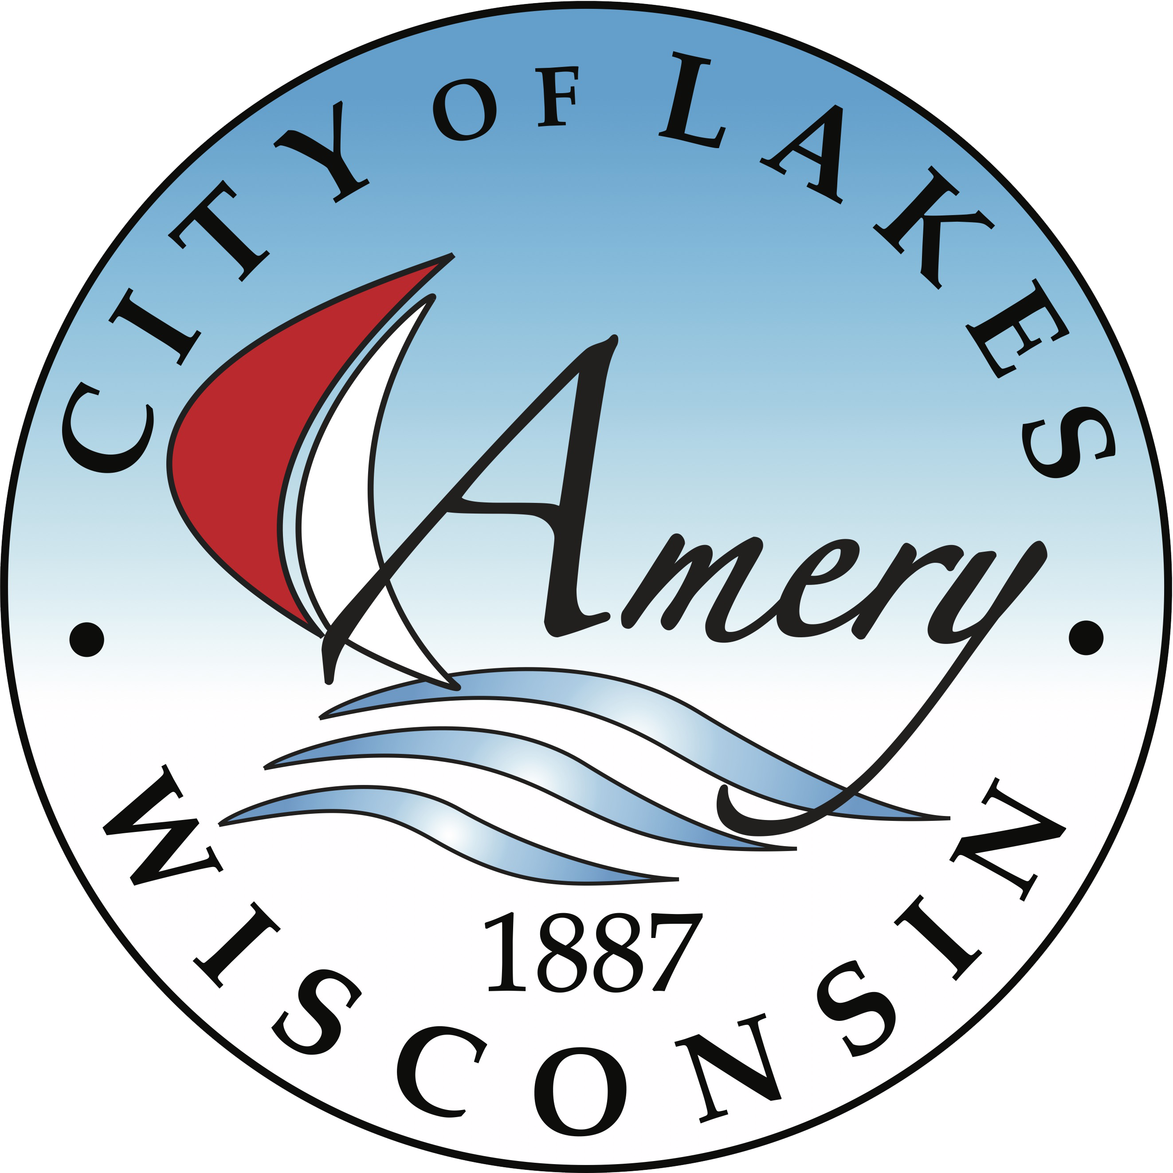

Call to Order

Order of Items | AGENDA ITEMS
1 | Approval of Minutes from 02-03-2026
2 | Polk County Recycling Update
3 | March Topic – Medication Disposal
4 | April Topic- Earth Day/Earth Month
5 | May Topic – Lawn care waste disposal and promotion of non-pesticides for lawn care.
6 | Adjournment
Adoption of Agenda

Respectfully Submitted.

Lisa Gunderson
Deputy Clerk-Treasurer
**Posted January 29^{th,} 2026, on the city website (www.amerywi.gov); and at Amery City Hall, Amery Public Library, and the Amery Police Department.
Next meeting is scheduled for April 8th, 2026 at 9:30 AM

